Contents
RBAC 2
Role Vs ClusterRole Vs RoleBinding Vs ClusterRoleBinding 2

RBAC
- Role-Based Access Control
- Approach that is used for restricting access to users and applications on the system/network
- Adding/removing permissions and setting up rule
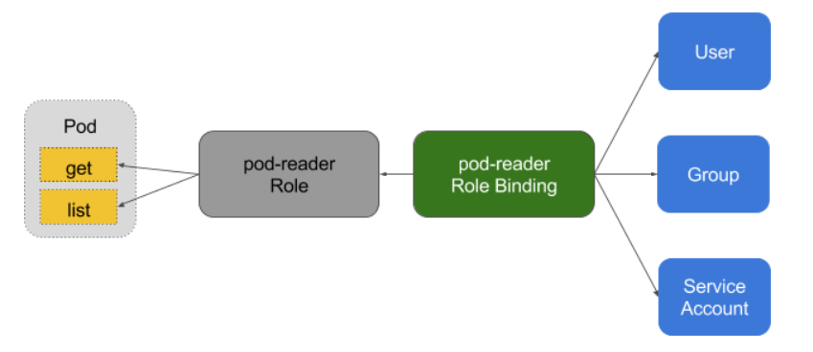
- enable RBAC manually for a Kubernetes cluster you need to start the cluster with the flag — authorization-mode=RBAC
- RBAC in Kubernetes infrastructure is implemented through Role, ClusterRole, RoleBinding, and ClusterRoleBinding.

Role Vs ClusterRole Vs RoleBinding Vs ClusterRoleBinding
Role | ClusterRole | RoleBinding | ClusterRoleBinding
Assigning resources for a namespace | Assigning resources for a cluster | Granting permission to a subject in k8s | Granting permission to a subject on a cluster level in all namespaces
Set of permissions | Set of permissions | Assign those permissions | Assign those permissions
 |  | Subject are nothing but user, services or groups trying to access k8s api

